Let’s make use of some basic commands applying them in an exercise.
To start open Draftsight, go to file new, choose standard.
Locate the tab called Sheet 1 and click on it.
Now we will draw the Border lines ( refer to the border handout)
Now we will go to the Model display, click on the model tab.
Now we will display the Grid
At the command prompt type: Grid, then enter
Type: .50
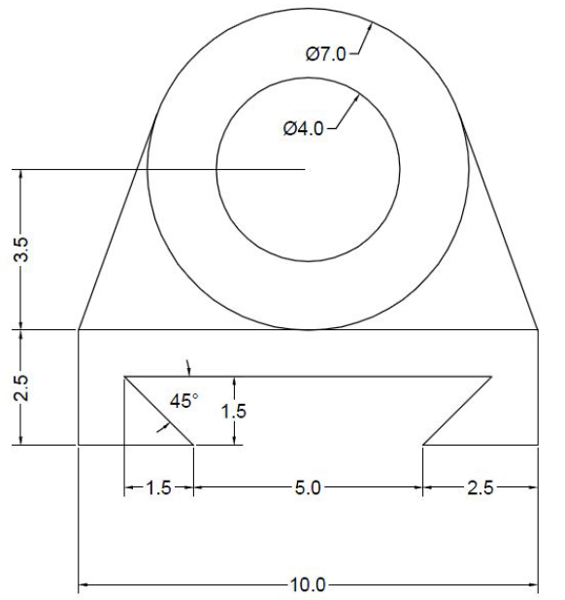
I need to mention the use of the ORTHO mode before proceeding.
The ORTHO mode helps you have exclusively straight lines in a vertical of horizontal direction when it is activated.
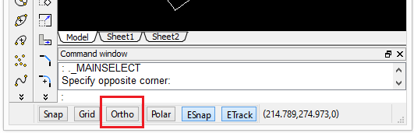
alright!
Now we can start.
Use the LINE command to draw a circle with diameter 7 units and a circle with diameter 4 units both having the same center.
To draw a circle
You need to use Circle command.
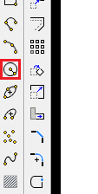
After a click on the icon
You will see the following lines appear in the command window
Options: 3Point, 2Point, Ttr, TTT, Enter to exit or
Specify center point»
Click on the drawing window to indicate the center point of the circle.
Now type “D” and Enter 7 to draw a circle with diameter 7.
Do the same to draw the circle of diameter 4, but make sure ESnap is activated to allows you choosing the same center with the previous circle.
You should at this point have both circles drawn.
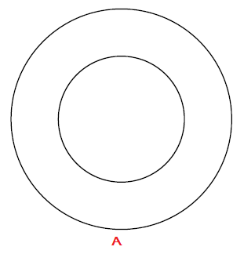
Draw a line (5 units) starting from the point A. Make sure ESnap and ORHTO are activated while drawing the line.
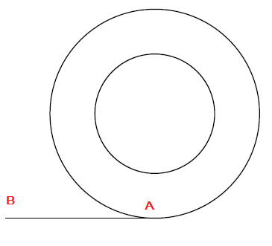
Now draw a line from the point B to C (2.5 units)
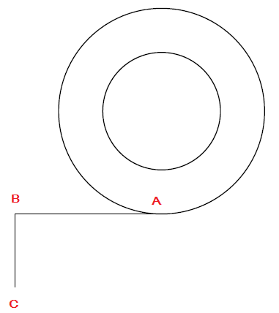
Draw the following lines starting from the known point to the unknown point.
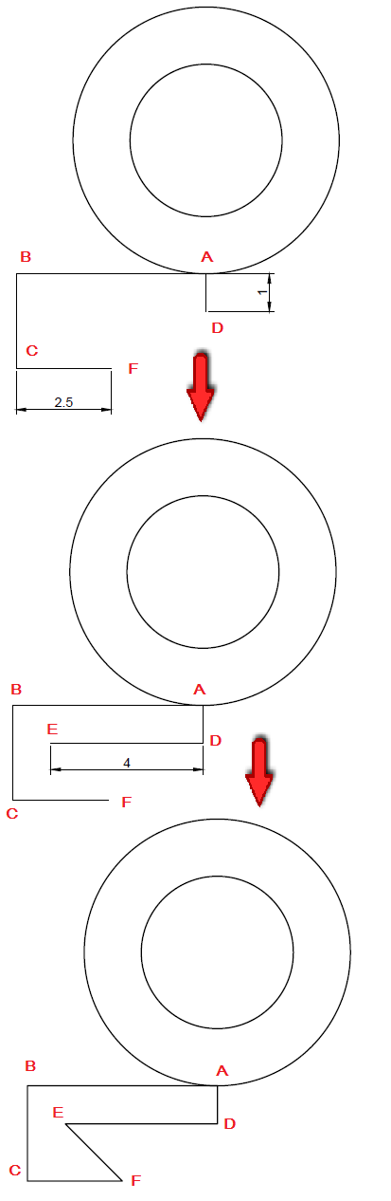
Joining E and F with a line will be easy since we have already drawn elements having these 2 points belonging to them.
Now delete AD, and draw the line BG.
(Star from the point B going upward, once u get around where the point G is to be, hover around that position, and let Draftsight show you were to drop the other end of your line)
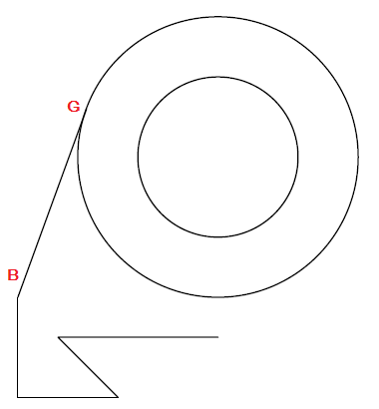
Now you can simple use the MIRROR command on what we have to get the right part of this design.
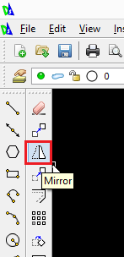
Getting…
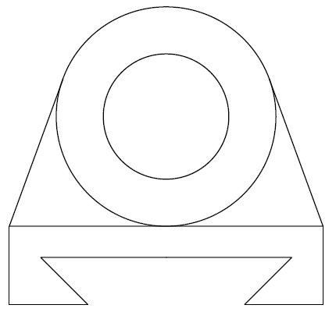
This same exercise was tackled on the third day of the last series of 2D AutoCAD exercises, you may need to have a look at how we use another approach to model it last time.

